HHCA Member Manual
2022-2023

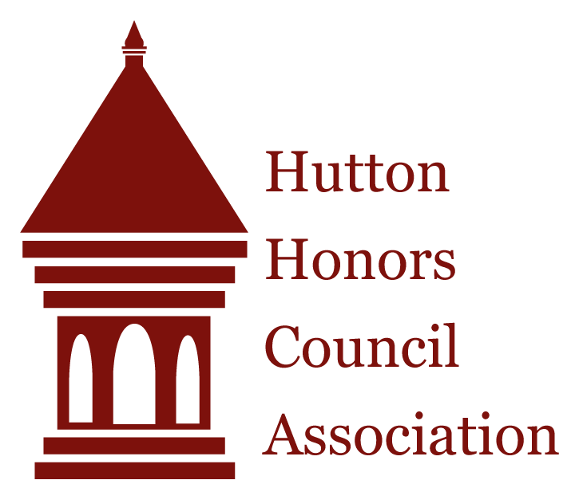

Table of Contents
Overview 3
HHCA Structure 3
HHCA Executive Board 4
HHCA Council Positions 5
HHCA Council Responsibilities 6
Meeting Requirements 7
Communication Policies 8
Event Marketing Policies 9
Event Planning Timeline [Suggested] 10
Three Strikes Policy 11
University Compliance 11
Advice for New Members 12

Overview

Our Mission and Purpose
Our mission is to connect Honors students to the Hutton Honors College (HHC) and to each other by building community among students on campus. We also aim to build students’ practical and facilitative leadership skills by helping students plan and execute meaningful social, academic, and service events for first year students living in residence halls, and by creating interest area specific events for upperclass students.

History
The Hutton Honors Council Association (HHCA) was founded in 2006 in an effort to bring HHC students together to study, network, and socialize. Today, there are honors councils serving freshmen in at least twelve residence halls (the exact number varies year to year). The HHCA also serves upper-class students via campus councils focused on academic interests or career paths. This organization has grown exponentially since its formation with over 170 HHC students now holding leadership positions each year. It is the largest Honors organization on campus.

HHCA Structure

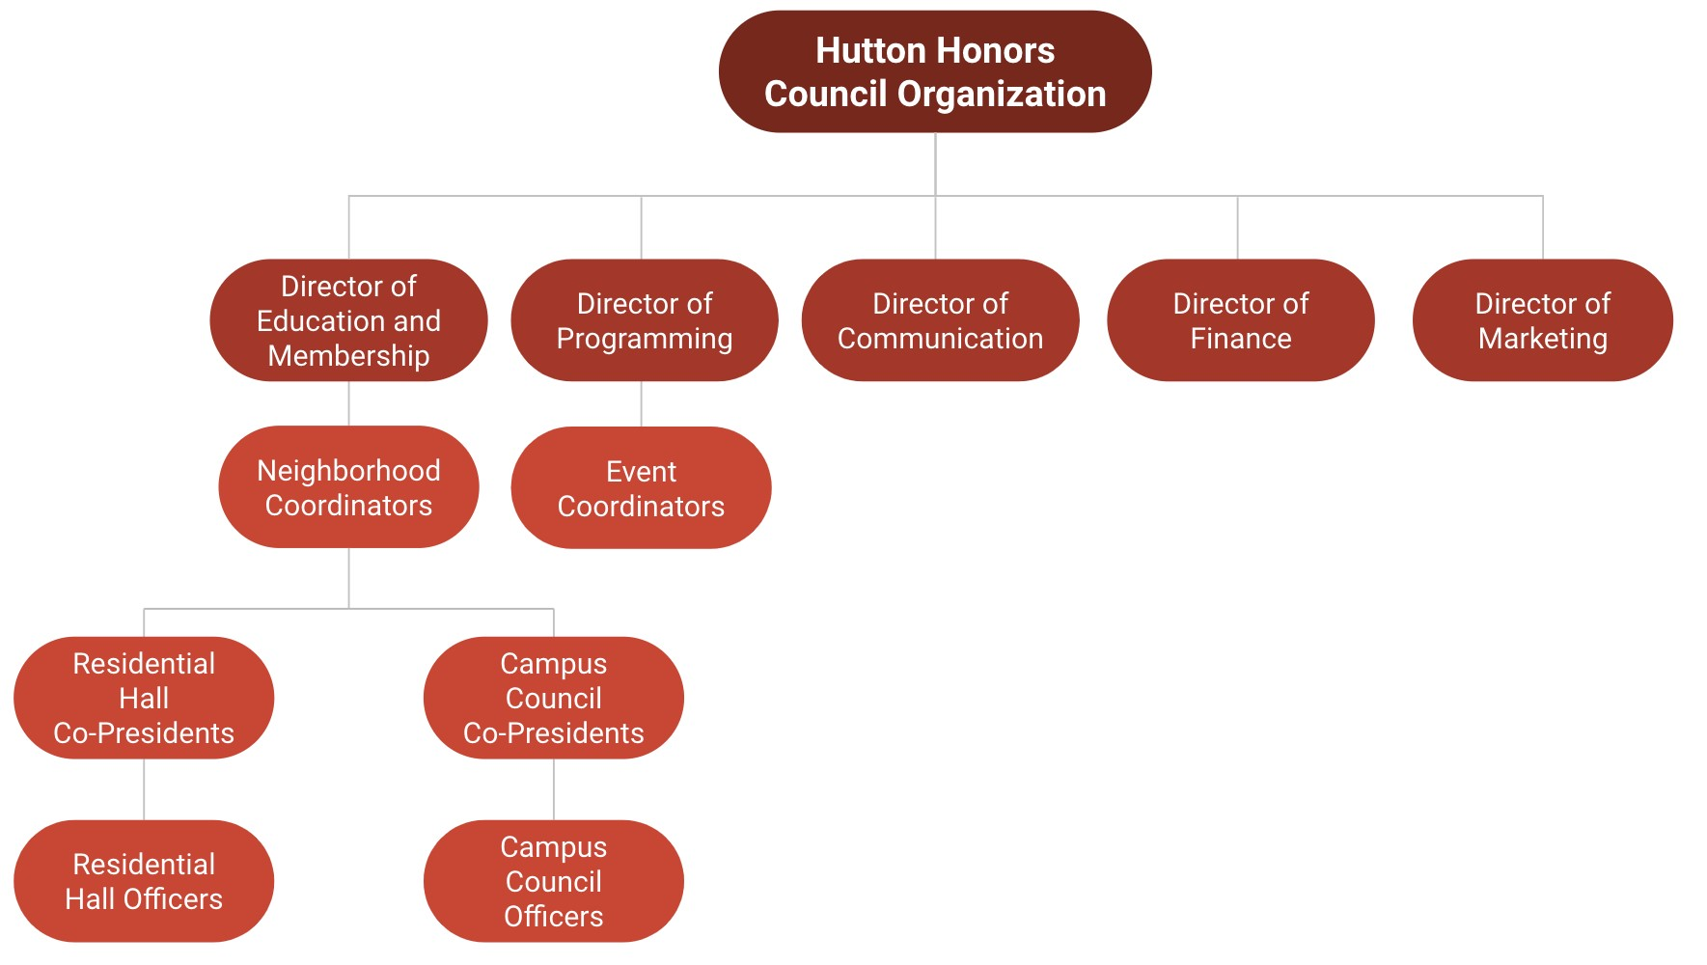

HHCA Executive Board
Advisor: Dr. Lynn Cochran (lcochran@indiana.edu) As the Assistant Dean of the Hutton Honors College at Indiana University, one of Dr. Cochran's many roles includes advising all HHCA positions and meeting with students regularly to discuss council progress and events.

Directors
The directors are a group of junior and senior students who have previous Executive Board experience. Each director serves an assigned neighborhood, reads monthly reports, leads meetings, and works to ensure that HHCA runs smoothly. Specific director positions and responsibilities include, but are not limited to:
- Director of Education and Membership: Oversees the neighborhood coordinators and mentorship coordinator.
- Director of Finance: Manages all HHCA financial duties and records.
- Director of Communication: Maintains and distributes internal documents and emails, and the Google Drive
- Director of Marketing: Operates the HHCA website, social media accounts, and Google calendar.
- Director of Programming: Oversees the event coordinators.

Event Coordinators
The event coordinators (ECs) work to plan events and foster community on behalf of HHCA for the Hutton Honors College. They are responsible for writing funding proposals, organizing space reservations and vendor orders, and creating timelines for Hutton-wide events. Each event coordinator is assigned an additional special role, the details of which can be found in the EC Manual.

Neighborhood Coordinators
Each neighborhood coordinator (NC) leads an interview team, serves as the advisor to an assigned neighborhood or group of campus councils, and attends council meetings and events. Neighborhood coordinators serve as advisors, mentors, and the link between the executive board and the councils. Being a neighborhood coordinator is often referred to as the “heart of HHCA.” Neighborhood coordinators are vital in facilitating the development of professional skills in co-presidents and officers.

Selection Process
The selection process occurs during the spring semester and is conducted by the outgoing Executive Board and the advisor, with input from the incoming directors. Co-president and officer positions are selected from interviews conducted at the start of the fall semester by the new Executive Board. Each Executive Board position receives its own separate manual. For further position descriptions and contact information, refer to the Google Drive or HHCA website (https://hhca.indiana.edu).

HHCA Council Positions

Co-Presidents
Each council will be led by a pair of co-presidents who facilitate the planning of events and activities for their HHC student community, create leadership opportunities for officers, and provide occasions for council members to bond together. Specifically, the pair should facilitate at least one honors council meeting per week and ensure that their council achieves their assigned responsibilities.

Both co-presidents report directly to their assigned neighborhood coordinator, assigned director, and the Assistant Dean of the Hutton Honors College, who also serves as the faculty advisor to HHCA.

Each co-president will be responsible for either communications or finance. In residential councils, the co-president of communications will receive access to the Listserv information that will allow them to advertise to the entire residential hall. In campus councils, the co-president of communications will coordinate with Dr. Cochran to market their council's events to the broader student body. The copresident of finance will manage event funding proposals and keep track of all financial records.

The co-president partnership model is designed so that the partners work together and assume a joint set of responsibilities. The co-presidents maintain final accountability for their council, and they must work together throughout the year. Co-presidents assume the following responsibilities in addition to those listed on the co-president contract:

- Delegate appropriate roles and responsibilities to each officer
- Commit at least 3-6 hours to HHCA each week
- Facilitate one honors council meeting (with a corresponding agenda) per week
- Attend all Leadership Board meetings and Member Workshops
- Respond to communication from their neighborhood coordinator, other Executive Board members, and HHC administration within 24 hours and in a professional manner ● It is strongly recommended to attend:
  - one residential council event outside of their own council each semester (does not apply to campus council members)
  - one campus council event each semester (outside of their own council for campus council members)
  - one event planned by the Executive Board
- Complete monthly reports according to the prompts provided by the faculty advisor
- Complete feedback evaluations as facilitated by the Executive Board
- Complete an end-of-year letter to their successor

Officers
Officers will work alongside the co-presidents to accomplish their council’s objectives. Officers will volunteer for or be assigned various tasks each week, such as: designing an event flier, recording meeting minutes, reaching out to businesses for donations, etc.
Officers report to both co-presidents and their neighborhood coordinator and are responsible for the following throughout the year:

- Work with other council members to accomplish council objectives and responsibilities ● Commit at least 2-3 hours to HHCA each week
- Attend all weekly honors council meetings ● Attend all Member Workshops
- It is strongly recommended to attend:
  - one residential council event outside of their own council each semester (does not apply to campus council members)
  - one campus council event each semester (outside of their own council for campus council members)
  - one event planned by the Executive Board
- Respond to communication from other HHCA members within 24 hours and in a professional manner
- Complete feedback evaluations as facilitated by the Executive Board

HHCA Council Responsibilities
HHCA council responsibilities focus on event planning, which require considerable time, planning, and effort. These events may be partnerships, but should not be hosted entirely by another group. Events during the 2022-23 year may be held online via Zoom or in person, depending on ongoing IU mandates as well as council member preferences.

Residential Councils
Each residential council is responsible for planning two of the following per semester:
- One academic event aimed at educating the residential community on a particular topic or assisting them in their studies.
- One social event aimed at involving the residential community in a fun, social activity.
- One philanthropic event aimed at helping improve the Bloomington campus or assisting a local organization

Additionally, all councils must plan one council bonding event per semester. You are encouraged to meet more often in informal council social gatherings.

Campus Councils
Each campus council is responsible for planning the following:
1. At least four large events per year (two each semester)
Campus councils are given more autonomy in choosing the types of initiatives that they will pursue. However, these events must align with their academic area and are expected to be significantly larger in scale than residential council events. These events may involve partnerships with other IU offices or student organizations.
Additionally, all councils must plan one council bonding event per semester. You are encouraged to meet more often in informal council social gatherings.

Meeting Requirements

Weekly Council Meetings
Every council is expected to meet weekly to discuss event planning and stay on track for accomplishing council goals. These meeting times will be established by the co-presidents and neighborhood coordinator at the beginning of each semester and must remain consistent week-to-week.

Council officers must attend these meetings and are allowed no more than two absences a semester unless special circumstances arise. Additional absences will be evaluated by the council’s co-presidents with the advice of the neighborhood coordinator. The co-presidents will be in charge of monitoring weekly attendance (but may delegate this responsibility).

Leadership Board
The HHCA Leadership Board (LB) includes the members of the Executive Board as well as the copresidents from each HHCA council. LB serves as an opportunity for HHCA leaders to connect with one another and share important HHCA-wide updates and events. Co-presidents should share important updates from LB with their councils during weekly council meetings.

LB meets every other Friday from 4:00 – 5:00 PM. LB members must be available to attend these meetings and will receive the meeting schedule at the beginning of each semester. LB members may miss one LB meeting per semester. They must contact their neighborhood coordinator at least 24 hours in advance of their absence with a legitimate reason for missing. Further absences will result in a meeting with the HHCA directors and a case-by-case action plan.

NOTE: Council officers who wish to apply for EB next year may become eligible. To do so, they must attend all Member Workshops and all LB meetings following their nomination in mid-October. They are also required to submit monthly reports along with their co-presidents. If you have any questions about this process, you're encouraged to ask your neighborhood's director.

Member Workshops
Member Workshops are designed to allow ALL HHCA members to work together and get to know each other. These workshops will cover various topics focused on leadership and professional development.

Member workshops will take place two Friday's per semester from 4:00– 5:00 PM. All HHCA members must be available to attend these meetings and will receive the meeting schedule at the beginning of each semester.

Communication Policies

HHCA-Wide and Council Communication
Our official communication platforms will be IU Email, the HHCA Canvas page, the HHCA Google drive, and GroupMe.

I. Canvas page: Event posting and advertisements, important links, modules for member workshops, attendance tracking, and a staff list II. Email:
- Internal Email: You will receive emails regarding internal HHCA business, updates, and schedules and are responsible for all communication sent regarding HHCA to your student email.
- External Email: Email is the official mode of communication for IU, and when coordinating with other parties on campus, you may need to send emails to IU faculty or
Bloomington community members. Your NC must approve ALL emails to IU
Administration (e.g. faculty speaker) and adults within the Bloomington community (e.g. Director of Boys & Girls Club) before they are sent, and they should be copied on all correspondence thereafter. Dr. Cochran and your NC must both be copied on all emails sent to anyone outside of HHCA.
- Google Drive: All HHCA files, such as: event planning and finance protocols, position manuals, sample documents (event planning sheets, email templates, etc.). Each council must use Google Drive to store their event materials, meeting agendas and minutes, and other important files.
- GroupMe: Individual council and HHCA neighborhood-wide communications. In individual council GroupMe chats, please include your neighborhood coordinator in order to keep them up to date with important dates and announcements.

Please respond to all council and other HHCA communication within 24 hours.

Google Calendar
HHCA members are also invited to add the HHCA Google Calendar, which includes dates for LB and Member Workshops (such as Member Orientation).

Monthly Reports
Co-presidents are responsible for submitting 1-2 page monthly reports to their neighborhood director and Dr. Cochran via email. Dr. Cochran will send out a monthly email reminder that will include a prompt for that month’s report. All members are encouraged to write about their insights into HHCA and offer critiques about how the organization could improve. In addition to answering the prompt, the report should include a brief update on your council and on how you are doing personally. We are very interested to know how you are doing as a person, so feel free to share any academic and personal college experiences. Reports are read by your director and Dr. Cochran, and no information is shared beyond the group of directors. If you ever need to share information with Dr. Cochran privately, you can send your report only to her and mention that you would like it to remain private.
Your report must have your name, the date, your council, and your position. Additionally, your report must be submitted as a Word document. Reports are due by midnight on the dates listed on the agendas. Officers selected to attend LB must also submit monthly reports in order to be eligible to apply for EB.

Event Marketing Policies

IU Listserv Email
The communications co-president of each council is responsible for sending out emails to the listserv for honors students in their respective council community to advertise any upcoming events. The protocols outlined below must be followed when composing and sending an email to this listserv. Any email sent to the listserv must be approved by your NC first.
- Always send using your iu.edu email address and put the listserv address in the bcc line. The message must be sent from an IU email account, or it will not successfully be sent.
- Triple check spelling and grammar and refer to the official HHCA listserv email guide for proper formatting and content.
- Always include your HHCA title/role when signing an email. For example, the co-president of Teter would sign an email with their name followed by ‘HHCA Teter Council Co-President”. Do NOT overload students’ inboxes. For events, send the invitation email at least one week prior to the event, followed by ONE reminder email the day before the event.

Promotional Fliers
Councils must design a promotional flier for each event, to be shared on social media and to be posted in their residential hall, (if applicable). It is strongly recommended to use Canva when creating posters. On fliers, please include “Sponsored by the Hutton Honors Council Association” and your council’s name, e.g. “Teter HHCA Council”

HHCA has the capacity to share promotional fliers for events on its main social media platform, Instagram (@iu_hhca), the HHCA website (https://hhca.indiana.edu/index.html) and the HHCA Canvas page. To request to have your event shared, please adhere to the following procedures:

- Complete your flier design at least 1 week prior to when you would like to have it posted. Proofread for typos, date, time, and location of the event.
- Share your flier’s design with your neighborhood coordinator to receive approval prior to moving on to the next step.
- Attach an image of your flier design along with a blurb of your council's event in an email to the Technology and Social Media event coordinator, who will post your flier and event information to HHCA social media platforms.

Event Planning Sheet
For every council event, you must fill out a brief planning document including: an event description blurb of less than 100 words for use in marketing; the name, time, date, location, and description of the event; a brief budget; and an image of the event flier. You can find a template for this document on the HHCA Google Drive and Canvas page. You must send this event planning sheet to your neighborhood coordinator at least 2 weeks before your event. Once approved by your NC, the event planning sheet should be forwarded to the director of marketing and social media EC for promotional purposes.

Event Photos
At every council event, you must be sure to capture a small photo record and upload these photographs to your council’s Google Drive folders.

Event Planning Timeline [Suggested]
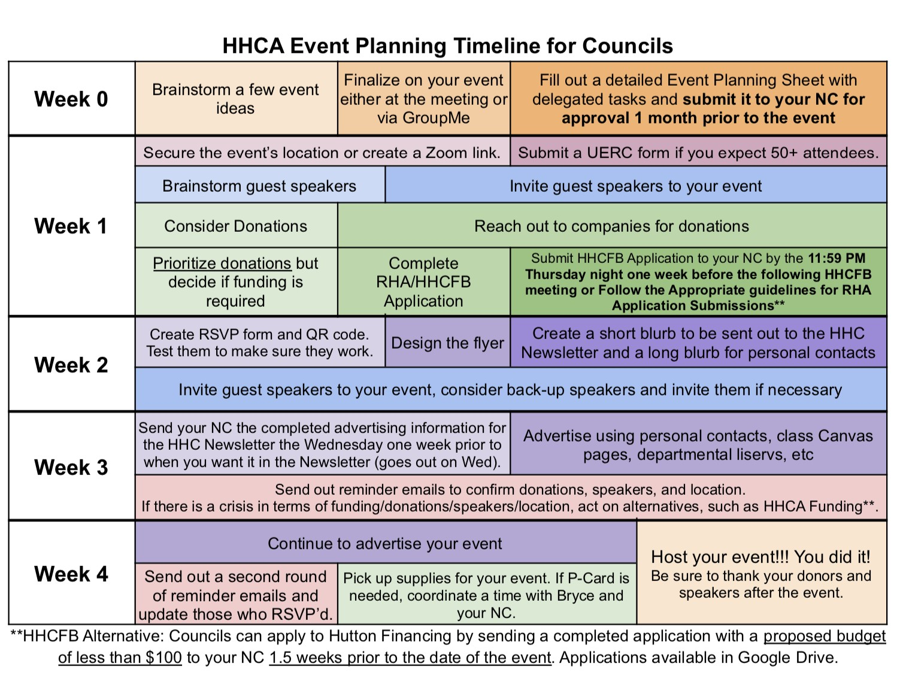

Three Strikes Policy
The HHCA operates on a “Three Strikes Policy” in order to address irresponsibility or inappropriate behavior within the organization. If an HHCA member has an issue, the issue will be addressed first by the neighborhood coordinator. A second offense will result in a sit-down meeting with the neighborhood coordinator and a director. Upon the individual’s third offense, they will be asked to step down from the position at the discretion of the directors and faculty advisor. Note that issues of significant severity may warrant an acceleration of the “Three Strikes Policy” and/or further reporting to university officials.

University Compliance
The Hutton Honors Council Association allows any interested student to participate in, become a member of, and seek leadership positions in the organization without regard to arbitrary consideration of such characteristics as age, color, disability, ethnicity, gender, marital status, national origin, race, religion, sexual orientation, or veteran status.

This organization shall comply with all Indiana University regulations, and local, state, and federal laws.

Non-Hazing: Hazing is strictly prohibited. Hazing shall be defined as any conduct which subjects another person, whether physically, mentally, emotionally, or psychologically, to anything that may endanger, abuse, degrade, or intimidate the person as a condition of association with a group or organization, regardless of the person’s consent or lack of consent.

Personal Gain Clause: This organization, if raising funds, shall ethically raise and distribute profits from organizational functions to either the organization or to members who provide a service that directly benefits the organization. Individual members may not receive compensation form for-profit companies if acting as a representative of a student organization.

Advice for New Members
Councils:
- A crucial part of being a leader is gaining an understanding of how other people communicate and adapting to their style so that you can easily get your ideas across.
- Start out each meeting with an icebreaker to get everyone comfortable and talking
- Have your bonding event with your council as soon as possible. It is crucial to get to know one another and form amicable relationships before you start working – this will make the event planning process easier, and help to form friendships.

Events:
- Make events on Tuesdays, Wednesdays, and Thursdays; students are usually available! ● Try to figure out what could potentially go wrong and always have a backup plan ● Have food! Free food is one of the best incentives that bring students to events.
- After an event, have a de-briefing. Discuss with your council: what went well and what can be improved?

Funding:
- Reach out to businesses and ask for donations.
- There are many resources for funding such as RHA, the HHC, and the HHCA funding opportunity.
- Document any payments you make for your council and keep all receipts.

Other:
- Be creative, flexible and patient
- Familiarize yourself with our Google Drive! All protocols – for finance, communication, event planning, etc. – are posted here. Also, each council has their own folder to upload meeting minutes, meeting agendas, funding request forms, and event-planning sheets.
- Check your email every day, and encourage your officers to as well!
- Proofread your reports, fliers and e-mails.You are representing the Honors College so sound personable, but professional.

You will have good events and you will have bad events, but everyone does! It is ok to make mistakes; the event planning process is one you continually learn from.

HHCA Sample Documents
2022-23

Meeting Agenda…………………………………………….………………..14
Monthly Report………………………………………………………………15
Listserv Advertising Email…………………………………………………..16
Donation Request Email……………………………………………………..17

Sample Weekly Meeting Agendas

Sample First Agenda
- Icebreakers/Introductions
- Announcements o HHCA Orientation on Sunday 9/25 at 1:00 pm
  - Attendance contract for the year
- Is this weekly meeting time good for everyone?
- Ideas for the council this year o Interests and Ideas – What do we want to do with our council? (One social, one academic event)
  - Goals for the year – Things we want to accomplish, anything to avoid
- Council Bonding Event o What times work for everyone? Restaurant ideas?
- Next Steps o Be thinking of ideas for what we want to do to talk about at the next meeting o Questions about HHCA as a whole?
  - Have a great week!

Sample Mid-Year Agenda
- Game Night – Social Event o 26th as a tentative date
▪ Push back a week? o Which games?
  - Comments/concerns
- Delegation of Roles for Game Night:
  - Andrea: contact the vendor o Lilia: design the flier o Mofe: reach out to tech. EC to get flier on Instagram and Canvas o Muskaan: update the ledger and submit funding application o Arianna: reserve the room
- Academic event o Friday the 22nd – Earth Day – at 5pm o Professor contacted?
  - Comments/concerns ● Other business?
- Have a phenomenal week and break!

Sample Monthly Report

Dom Alex
Co-President of Communications
Business Campus Council
10/28/21

Overall, the month of February was a successful one for the Business Campus Council. As a copresident, I have found that my communication and organizational skills have really improved, and I think the members on my council have become more comfortable taking on new responsibilities and coming up with their own ideas. Our brainstorming sessions have been great! In fact, my council has come up with tentative ideas for large events for the rest of the semester.

This month, we had one big event and one small event. For our big event, we had a professor come in and discuss sustainable food and the importance of eating locally. We had food from Bloomington foods, and students seemed to find the event very interesting. We were able to get funding from our dorm student government for this event, and we opened the event to all students (although most attendees were honors students). There were around 30 students present, and a few people from the other dorms in our neighborhood attended as well. We are thinking of following the event up by watching Food, Inc. this next month and having a discussion following it. For our small event, we attended a show at the auditorium and went out for ice cream afterwards. The show was wonderful, and about 15 people attended. It was a really laid-back atmosphere, and I think everyone enjoyed the chance to visit and get to know one another better. We are considering having another social, laid-back event like this one this month so that people can continue to meet one another.

This month has been very busy for me, and I have found that I have needed to lean on my council a bit more for support. Actually, I think this has been a good thing. I know that as a co-president, one of my primary roles is to facilitate leadership. At first, I had a hard time with this concept, and I wanted to do many of the tasks on my own, but I think I finally am beginning to grasp this idea. I have been delegating a lot more to my council, and consequently, I have learned what dedicated and reliable workers my council members are. I think many of them are interested in leadership positions in the HHCA next year, and I hope they continue with the organization.

Overall, things are going well. I am hoping the next month will be a bit less busy for me. I’m looking forward to continuing to work with my council and coming up with even better ideas for future events!

Sample Listserv Advertising Email

For Residential Councils:
Hello Teter Honors Students,
Mark your calendars, we are excited to invite you to a friendly Minute to Win It Challenge Night on Tuesday, February 15th from 6-7:30 pm in the NST Lounge in Teter Rabb. Get together four of your friends and fill out the form below to join us for several Minute to Win It themed games and a grand prize for the winning team: IU-themed gift baskets! We hope you can join us for this fun night with fellow honors residents of Teter. Bring your A-game!

Sign up here: https://forms.gle/bXc1YEZGu7jisRQD6

Reach out to Kylie Day with any questions— we look forward to seeing you soon!
Best,
Teter-Crimson HHCA

For Campus Councils:
Are you interested in networking with business professionals? Or learning about different career paths? Join the Hutton Honors Council Association's Finance Council virtually on Monday, October 26th, from 8:00-9:00pm!

You will have the opportunity to network with IU/Kelley alumni employed by an array of different business professions. Panelists include an Equity Research Analyst at Barclays in New York, an Investment Banking Analyst at William Blair in San Francisco and more! You will meet the professionals in a large group panel and ask questions during breakout sessions.

Please RSVP at the link (Google Form link) and email co-presidents Dom Alex (email) or Christina Whitten (email) with any questions. Thank you!

Sample Donation Request Emails

Sample Food Donation Request
To: Kroger
From: Indiana University’s Hutton Honors Council Association of Forest Residential Center Date: 8/18/2021
Re: Cake Donation for Alcohol Awareness Event

To the Management of the Kroger Bakery:
Indiana University’s Hutton Honors Council Association is a student-run organization whose mission is to create a sense of community among the Honors students on campus through organized events and activities. Our specific goal is to organize events for the Honors students living in Forest Residential Center; however, the events are open to all students.
This month, the Hutton Honors Council Association of Forest Residential Center is planning an Alcohol Awareness Event during Alcohol Awareness Week to take place on the evening of Thursday, October 23rd in Forest Residential Center. Our association has a very small budget that does not even cover food costs for one event, and we thus rely on the generosity of local food providers and other businesses to help make our events a success. The purpose of this event is to bring students together in a relaxed environment and educate them about the dangers of alcohol abuse.
For this event, we are expecting approximately 100 students. We would be extremely grateful if Kroger would be able to donate a sheet cake for attendees to enjoy at this event.
Please contact Leah Murray, Co-President of Communications for the Hutton Honors Council
Association in Forest Residential Center, at leamur@indiana.edu or 317-752-3505, with any questions. If you would like to speak with our faculty coordinator Lynn Cochran for any reason, she can be reached by email: lcochran@indiana.edu.
Thank you for your consideration,
Leah Murray
Co-President of Communications of Forest Residential Council
Hutton Honors Council Association leamur@indiana.edu

Sample Food Donation Thank You Note
To: Kroger
From: Indiana University’s Hutton Honors Council Association of Forest Residential Center
Date: 8/21/2021
Re: Thank you for your kind donation

To the Management of the Kroger Bakery:
We want to thank you for your kind donation. Our council has very little funding, so we are greatly appreciative of any help companies are willing to lend us. Your donation of a full sheet cake to our Alcohol Awareness event is so generous, and we know it will help make our event a success.
This event is put on by Indiana University’s Hutton Honors Council Association through Forest
Residential Center. The overall goal of the organization is to foster a sense of community amongst Honors students living in each dorm. Honors students live on all different floors, and without a program such as this, we might never have the opportunity to meet each other. This specific event is dedicated to alcohol awareness, as this week is Alcohol Awareness Week on campus. We have a speaker coming in from Indiana University’s Alcohol Drug Information Center to educate us on the dangers of alcohol abuse, and we have fun activities planned as well. We are confident that this event will be a success, and we again thank you so much for your kind generosity.
Thank you and take care,
Leah Murray
Co-President of Communications of Forest Residential Council
Hutton Honors Council Association leamur@indiana.edu

